**HPC ASSIGNMENT 13**

**lshw**:

user@LAPTOP-6QVE9SBJ:~$ sudo lshw

[sudo] password for user:

laptop-6qve9sbj

description: Computer

width: 64 bits

capabilities: smp vsyscall32

*-core

description: Motherboard

physical id: 0

*-memory

description: System memory

physical id: 1

size: 4GiB

*-cpu

product: Intel(R) Core(TM) i5-8265U CPU @ 1.60GHz

vendor: Intel Corp.

physical id: 2

bus info: cpu@0

version: 6.142.12

width: 64 bits

capabilities: fpu fpu_exception wp vme de pse tsc msr pae mce cx8 apic sep mtrr pge mca cmov pat pse36 clflush mmx fxsr sse sse2 ss ht syscall nx pdpe1gb rdtscp x86-64 constant_tsc arch_perfmon rep_good nopl xtopology cpuid pni pclmulqdq vmx ssse3 fma cx16 pdcm pcid sse4_1 sse4_2 movbe popcnt aes xsave avx f16c rdrand hypervisor lahf_lm abm 3dnowprefetch invpcid_single ssbd ibrs ibpb stibp ibrs_enhanced tpr_shadow vnmi ept vpid ept_ad fsgsbase bmi1 avx2 smep bmi2 erms invpcid rdseed adx smap clflushopt xsaveopt xsavec xgetbv1 xsaves flush_l1d arch_capabilities

configuration: microcode=4294967295

*-scsi:0

description: SCSI storage controller

product: Virtio console

vendor: Red Hat, Inc.

physical id: 3

bus info: pci@e91b:00:00.0

version: 01

width: 64 bits

clock: 33MHz

capabilities: scsi msix bus_master cap_list

configuration: driver=virtio-pci latency=64

resources: iomemory:90-8f iomemory:90-8f iomemory:90-8f irq:0 memory:9ffe00000-9ffe00fff memory:9ffe01000-9ffe01fff memory:9ffe02000-9ffe02fff

*-virtio0 UNCLAIMED

description: Virtual I/O device

physical id: 0

bus info: virtio@0

configuration: driver=virtio_console

*-display

description: 3D controller

product: Microsoft Corporation

vendor: Microsoft Corporation

physical id: 4

bus info: pci@efe4:00:00.0

version: 00

width: 32 bits

clock: 33MHz

capabilities: bus_master cap_list

configuration: driver=dxgkrnl latency=0

resources: irq:0

*-generic

description: System peripheral

product: Virtio file system

vendor: Red Hat, Inc.

physical id: 0

bus info: pci@f482:00:00.0

version: 01

width: 64 bits

clock: 33MHz

capabilities: msix bus_master cap_list

configuration: driver=virtio-pci latency=64

resources: iomemory:e0-df iomemory:e0-df iomemory:c0-bf irq:0 memory:e00000000-e00000fff memory:e00001000-e00001fff memory:c00000000-dffffffff

*-virtio1 UNCLAIMED

description: Virtual I/O device

physical id: 0

bus info: virtio@1

configuration: driver=virtiofs

*-pnp00:00

product: PnP device PNP0b00

physical id: 5

capabilities: pnp

configuration: driver=rtc_cmos

*-scsi:1

physical id: 6

logical name: scsi0

*-disk:0

description: SCSI Disk

product: Virtual Disk

vendor: Linux

physical id: 0.0.0

bus info: scsi@0:0.0.0

logical name: /dev/sda

version: 1.0

size: 388MiB

capabilities: extended_attributes large_files huge_files extents ext2 initialized

configuration: ansiversion=5 filesystem=ext2 logicalsectorsize=512 sectorsize=512 state=clean

*-disk:1

description: Linux swap volume

product: Virtual Disk

vendor: Msft

physical id: 0.0.1

bus info: scsi@0:0.0.1

logical name: /dev/sdb

version: 1

serial: 6fe43f8b-4429-46c1-8444-944420a5d6a9

size: 1GiB

capacity: 1GiB

capabilities: swap initialized

configuration: ansiversion=5 filesystem=swap logicalsectorsize=512 pagesize=4096 sectorsize=4096

*-disk:2

description: EXT4 volume

product: Virtual Disk

vendor: Linux

physical id: 0.0.2

bus info: scsi@0:0.0.2

logical name: /dev/sdc

logical name: /

logical name: /mnt/wslg/distro

logical name: /snap

version: 1.0

serial: 54b61250-d471-4149-bd74-bde99aac5bd8

size: 1TiB

capabilities: journaled extended_attributes large_files huge_files dir_nlink recover 64bit extents ext4 ext2 initialized

configuration: ansiversion=5 created=2024-03-13 10:42:07 filesystem=ext4 lastmountpoint=/distro logicalsectorsize=512 modified=2024-03-13 10:42:37 mount.fstype=ext4 mount.options=rw,relatime,discard,errors=remount-ro,data=ordered mounted=2024-03-13 10:42:37 sectorsize=4096 state=mounted

*-usbhost:0

product: USB/IP Virtual Host Controller

vendor: Linux 5.15.146.1-microsoft-standard-WSL2 vhci_hcd

physical id: 1

bus info: usb@1

logical name: usb1

version: 5.15

capabilities: usb-2.00

configuration: driver=hub slots=8 speed=480Mbit/s

*-usbhost:1

product: USB/IP Virtual Host Controller

vendor: Linux 5.15.146.1-microsoft-standard-WSL2 vhci_hcd

physical id: 2

bus info: usb@2

logical name: usb2

version: 5.15

capabilities: usb-3.00

configuration: driver=hub slots=8 speed=5000Mbit/s

*-network

description: Ethernet interface

physical id: 3

logical name: eth0

serial: 00:15:5d:97:fb:b6

size: 10Gbit/s

capabilities: ethernet physical

configuration: autonegotiation=off broadcast=yes driver=hv_netvsc driverversion=5.15.146.1-microsoft-standard-W duplex=full firmware=N/A ip=172.17.39.183 link=yes multicast=yes speed=10Gbit/s

**lsusb**:

List connected USB devices.

Input: -lsusb

Output: -

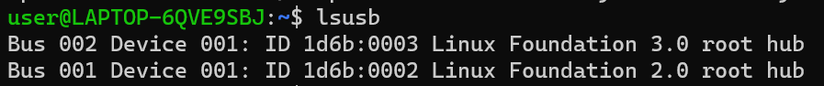

**lspci**:

List installed PCI devices.

Input: - lspci

Output: -

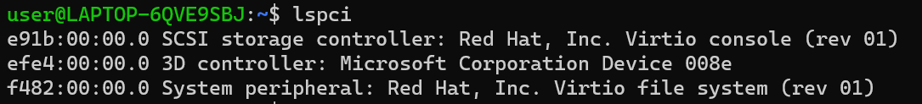

**lsblk**:

List block devices and their attributes.

Input: - lsblk

Output: -

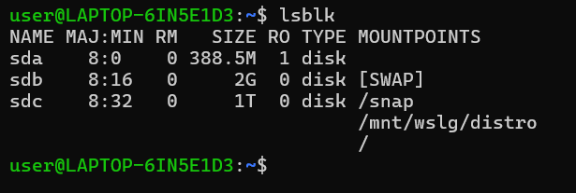

**lscpu**:

**df**:

Show disk space usage and availability.

Input: -df

Output: -

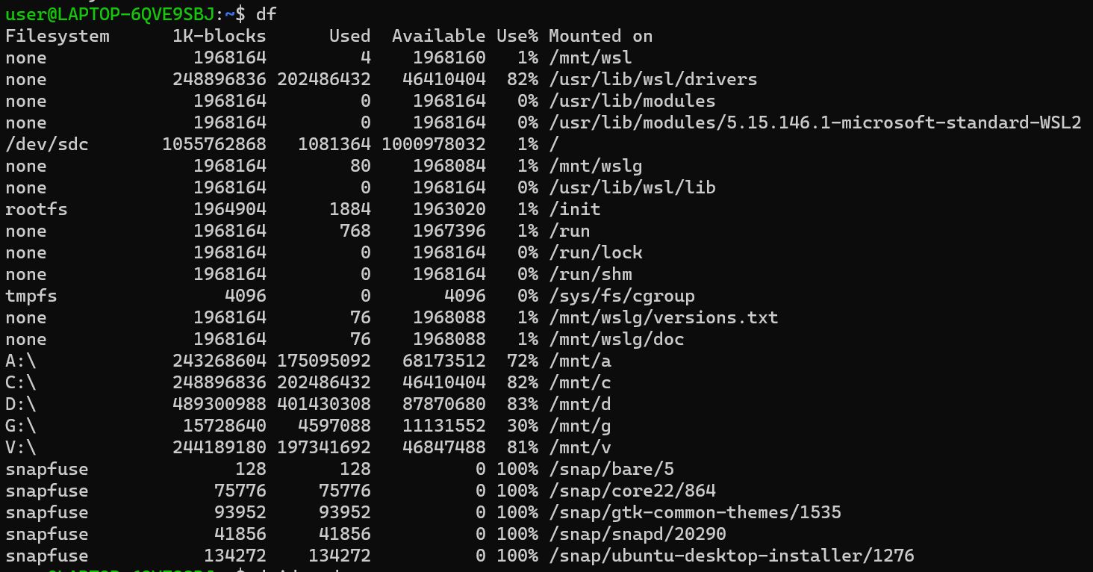

**dmidecode**:

Decode and display DMI table information.

Input: - dmidecode

Output: -

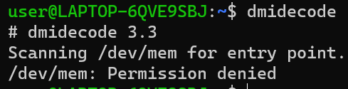

**ip a:**

Show IP addresses and network information for all interfaces.

Input: - ip a

Output: -

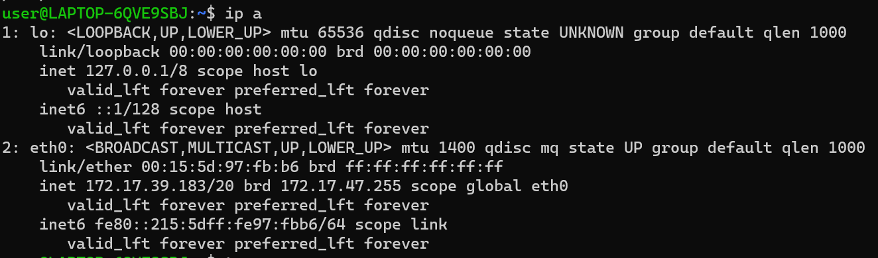

**top**:

Display real-time system resource usage.

Input: -top

Output: -

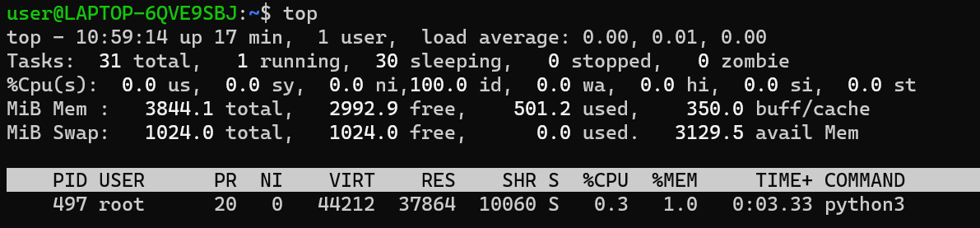

**htop**:

Interactive version of top with enhanced visualization.

Input: -htop

Output: -

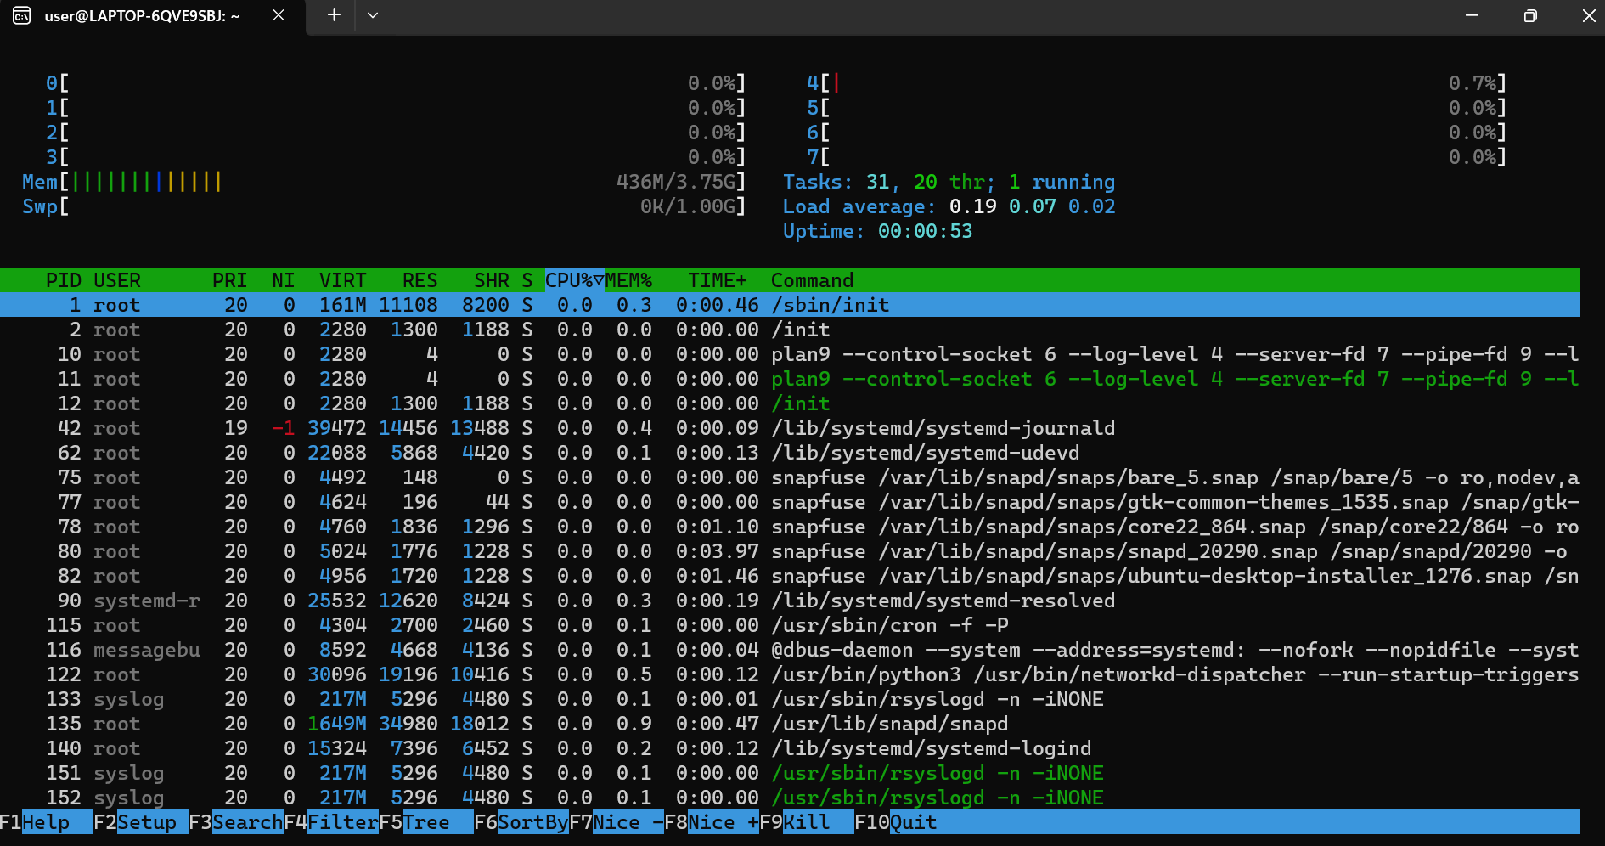

**nvidia-smi**:

Provide management for NVIDIA GPU devices.

Input: - nvidia-smi

Output: -

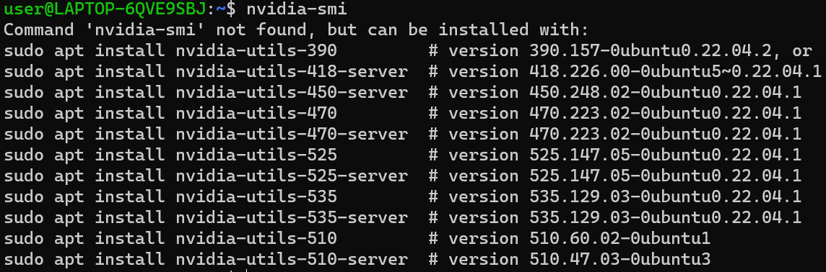

**lstopo**:

Generate graphical system topology representation.

Input: -lstopo

Output: -

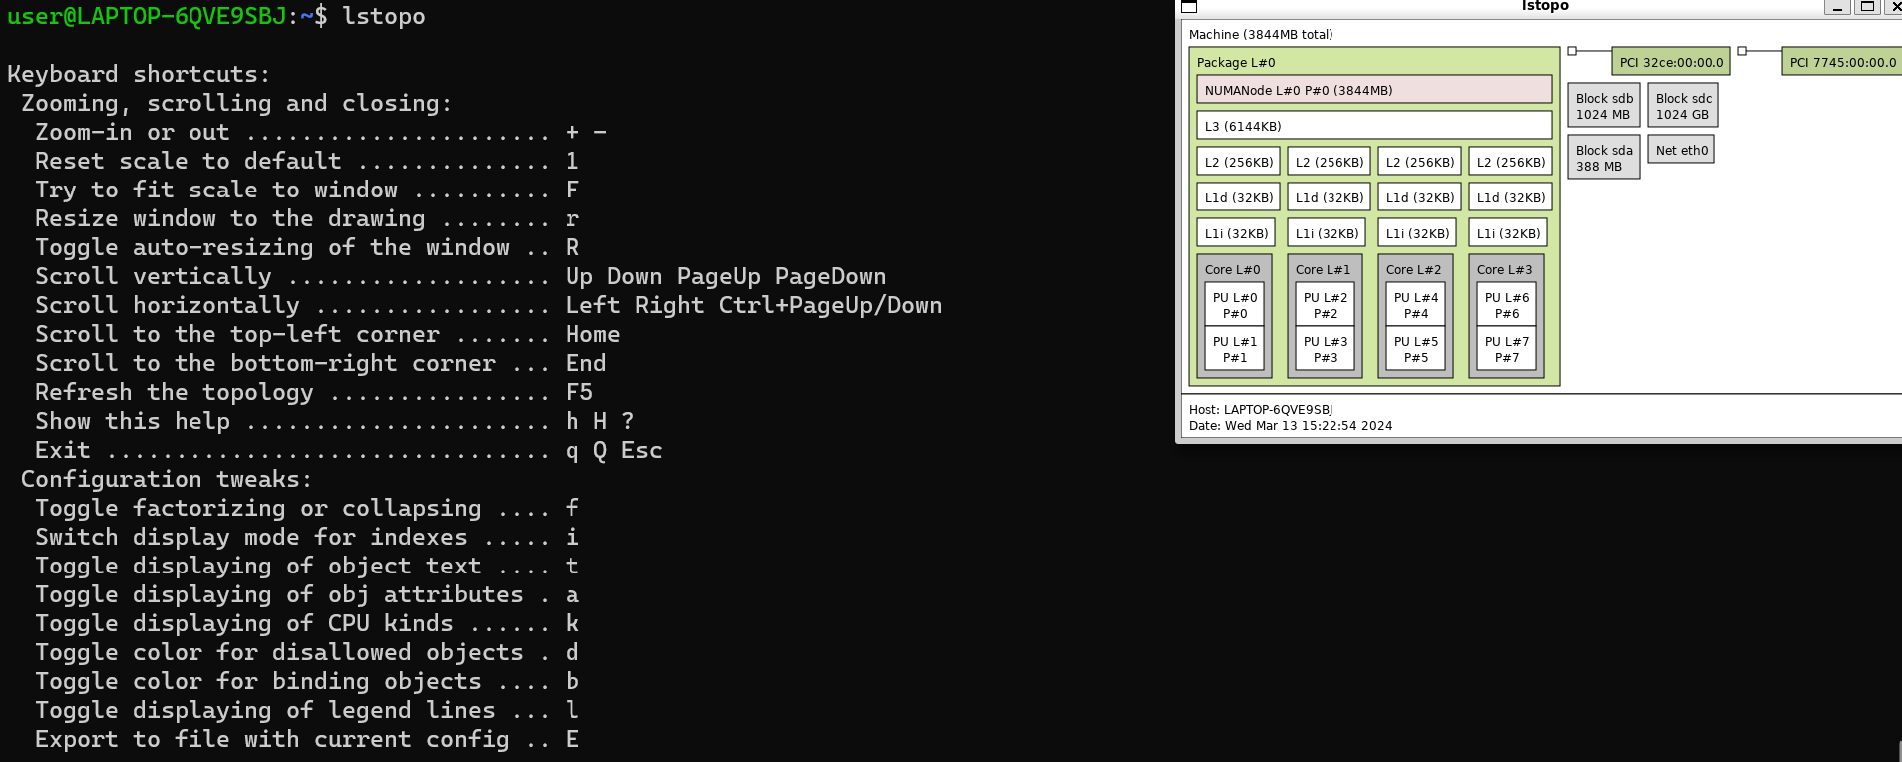

**perf**:

Collect and analyze performance data.

Input: -perf

Output: -

**numactl**:

Control and monitor NUMA policy on NUMA systems.

Input: - numactl

Output: -

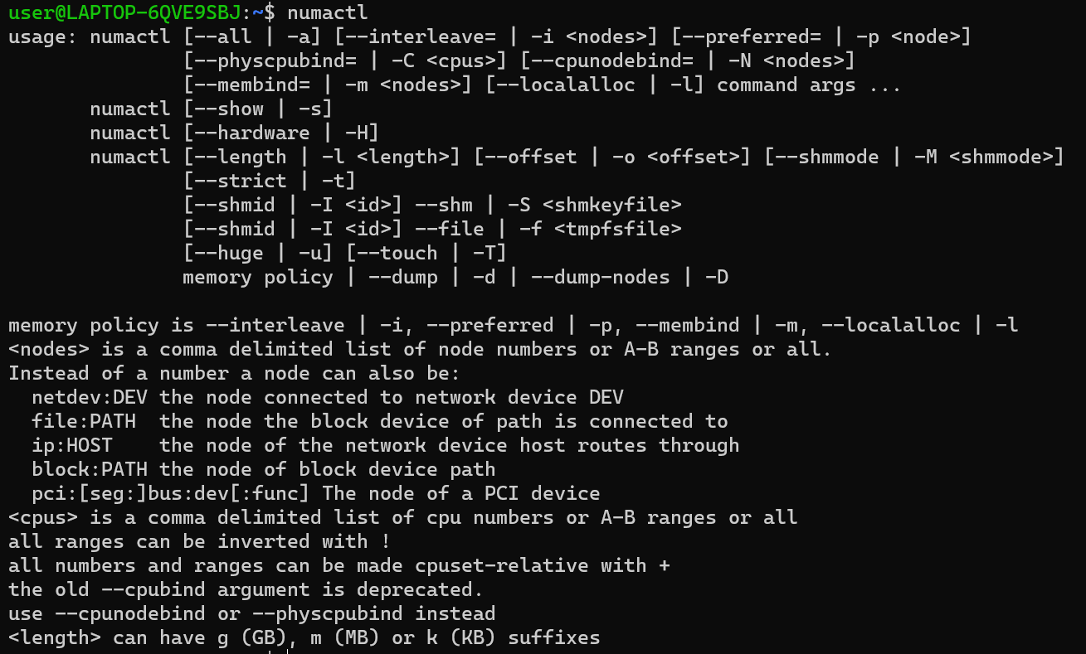

**sar**:

Collect and analyze system activity data over time.

Input: - sar -u 1 10

Output: -

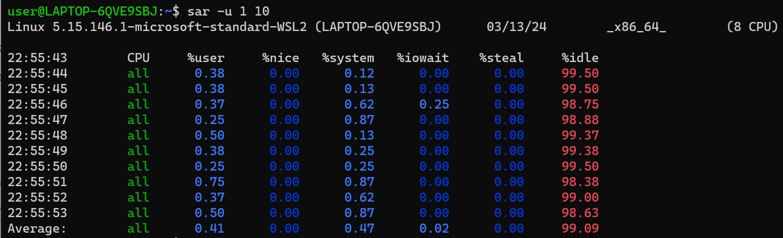

Input: - sar -r 60 5

Output: -

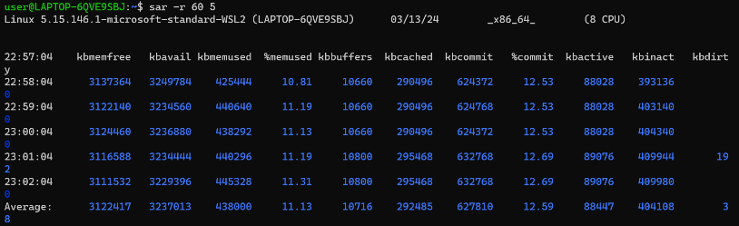

Input: - sar -d 5 30

Output: -

